Printing a Check in NAV
Go to the “Payment Journal”
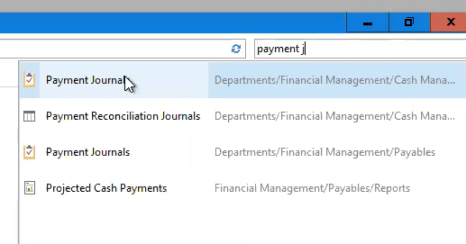
Which will open this screen
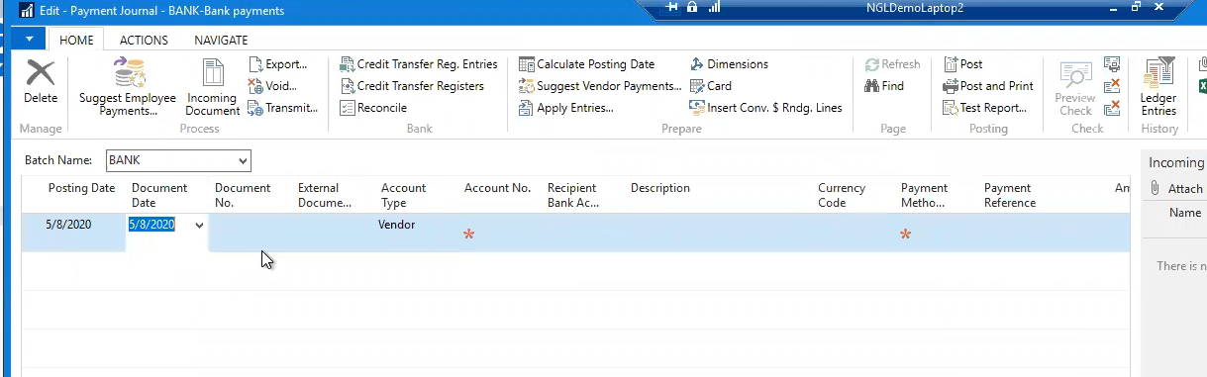
On this screen you need to fill out the following:
Account No.: example YRC - 10000
Payment Method: Pull down menu - Check
Applies-to Doc. Type: Example Invoice
Applies-to Doc. No.: opens to show you the available invoices that this payment can be applied to

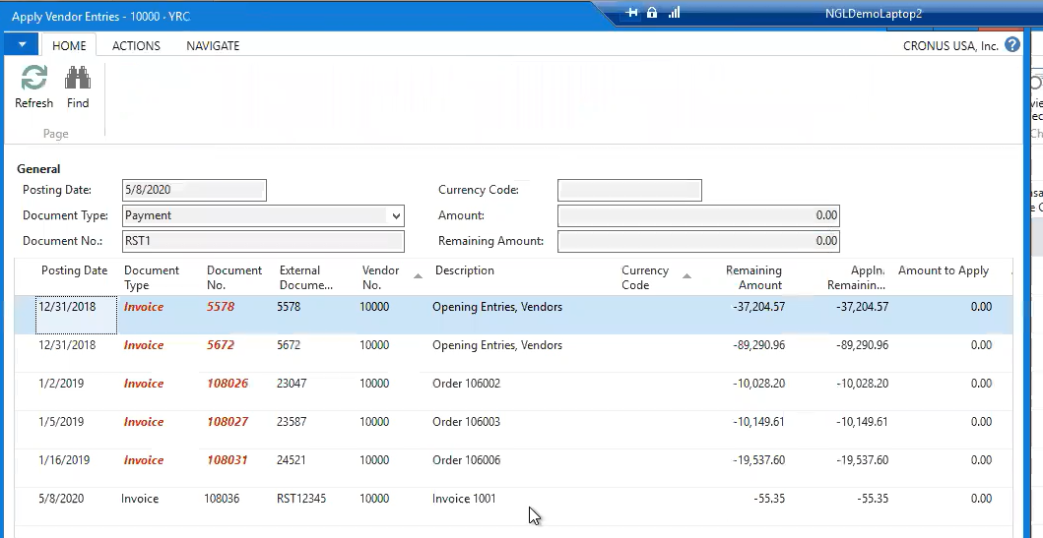

Bank Payment Type: Options are :
Computer Check – pick this one to do a check
Manual check - which is when you have run a check not with the system
Electronic Payment and Electronic Payment-IAT – direct deposit to the bank

By picking the document it brings in the amount for us on to the payment journal line.
You are now ready to print the check. In the top ribbon there will be a “Print Check”
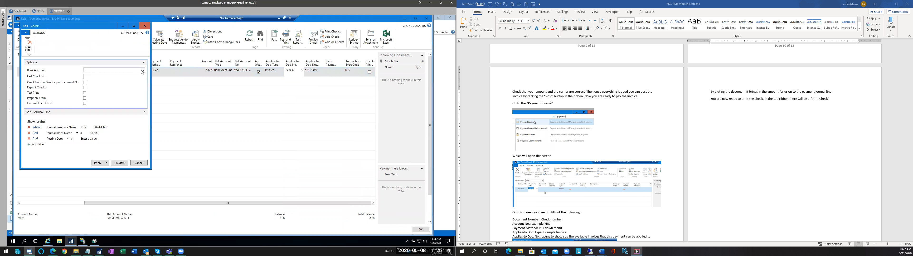
This will open this screen
You will need to use the pull down menu and pick the “Bank Account” and this will bring up the last check number and then you can print at the bottom to PDF.

